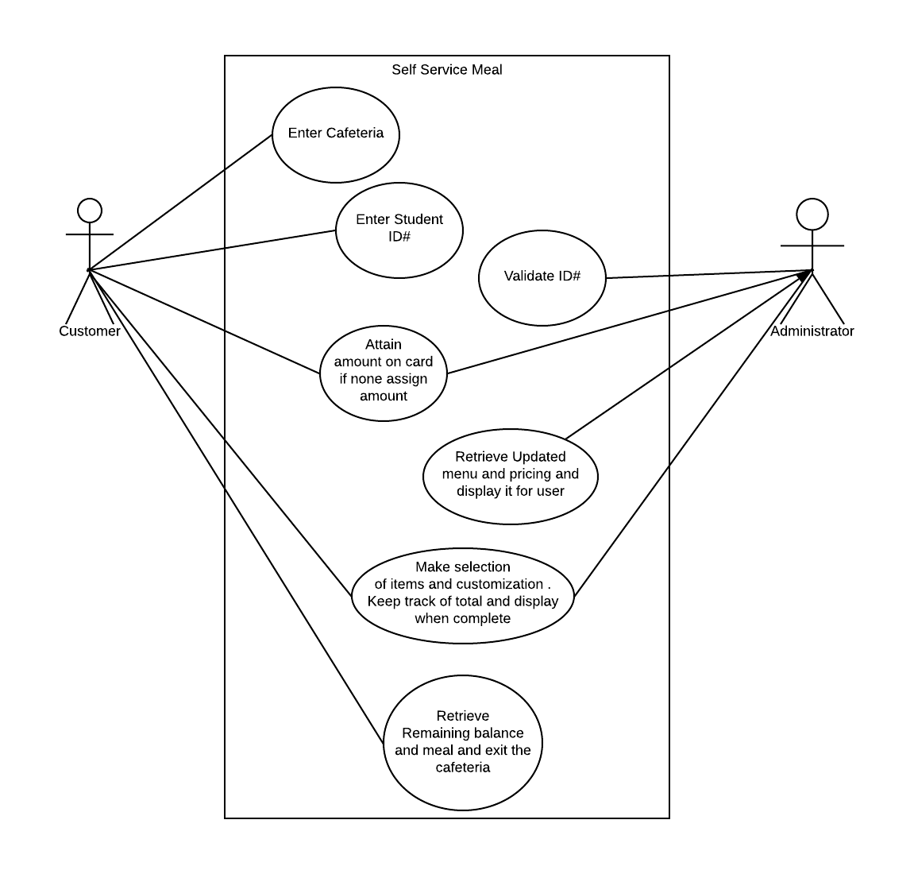

Use Case Specifications

**Use Case Descriptions**: The Self Service Meal Program is a program designed to be in school systems that age from (higher level elementary student to college kids) The goal of this system is to assist with busy cafeteria settings allowing the students to select their own meals on their own while the easier accessibility is hopefully going to increase profit for the school with more people wanting to use the cafeteria. The ideal functionality of the program is that a user will begin with approaching the machine housing the program, once the user has, they are prompted to enter their identification number which is verified in the background. Then they are ask a series of questions regarding the funds (The ideal would be the school would provide a list of student ID numbers so that the program could keep track of certain funds) . If the user does not have funds on their meal cards the user is given a certain amount so that he or she may be able to eat something, just not as much as if they would have their own funds. Upon completion of this they are given a menu and asked a series of questions depending on the items they have selected. While in the background the program is keeping track of the charges, at the end of the selection the user is prompted to go to the window for meal pick up and is told the remaining charges on the users account.

Some Use Case specifications contain 2 or more use cases to better explain and blend scenarios

**Use Case Name**: Enter Student ID

**Actors:** Any Student (With a ID and food card)

Self Service Machine

**Triggers:**

The user approaches the machine to order lunch

**Preconditions:** The Machine is operational

The user has a Student ID

**Post Condition:** The user received a validated message for ID from the machine

Normal Flow:

1. Customer enters the cafeteria and approaches the machine
2. The user enters his/her Student Id when prompted
3. The Machine Validates entry
4. Next screen for order process begins

**Use Case Name**: receives card information and assigns values

**Actors:** Student, Administrators

Self Service Machine

**Triggers:**

The user has passed the student ID verification process

**Preconditions:** The Machine is operational

Meal Card to enter machine

**Post Condition:** The Machines receives amount on card or assigns a amount for lunch for the day

Normal Flow:

1.User enters Meal Card

2. Machine checks balance, if empty and depending on how many free meals the user has the machine will assign a value for the day to eat.

3. Machine will display amount the user has for lunch

4. Proceed to next phase.

**Use Case Name**: Retrieve Updated Meal Pricing .., and Make Selections of Items and Keep Track.. Retrieve Remaining Balance and Meal’

**Actors:** Any Student (With a ID and food card)

Self Service Machine

Administrator

**Triggers:** The Machine receives food balance from card

**Preconditions:** The Machine is operational

The Machine received Meal Card Balance

**Post Condition:** The User Selects Meal from Menu and it is processed to kitchen

Normal Flow:

1. Machine retrieves meal options and pricing from Administrator
2. Machine then Displays meal options and pricing
3. User Makes Selections
4. Machine keeps track of total
5. Once User says they are finished, or their balance has hit 0. The Machine will display total and final meal selection.
6. User retrieves Balance if any and is prompted to go get meal.

End;